* Upon opening of Candidate project and successful builder- running in kestrel lead to Roslyn.EXE missing error – I was using vs 2019, app may have been created in vS 2017
* In order to fix- I had to Open the Package Manager Console in Visual Studio and execute the following command:

Update-Package Microsoft.CodeDom.Providers.DotNetCompilerPlatform -r

* I reviewed the code and data model and identified the entity relationship which was built (and also described in the test overview). About 1000 equipment (SKU) and 8 Model types existed as reference data and Cartons and Carton Details were the transactional data tables. A combination of Carton with an Equipment formed a carton detail.
* I was able to run the code next in IIS Express and then played around the user interface navigation/features
* I then read the requirements / bugs and enhancements requested in the coding test.
* I identified places in the code where potential code change has to be made and added a comment/note to myself

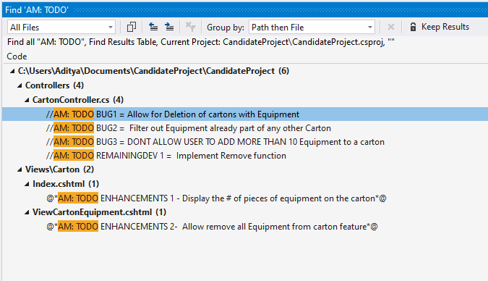

* They wanted to get the solution done within an hour, and hence there was not much scope for drastic refactoring of logic/further separation of concerns or application of any other design pattern like Command/MediaTr (Clean architecture)/ separate services which are interface based (SOLID) to remove direct db code access within controller. However, I do want to return some user-friendly messages during success/error situations from controllers (for Ex Carton not found or Equipment not found).

**Testing Screenshots**

1. **Pending Implementation**

**Implementation of the RemoveEquipmentOnCarton action on the CartonController**

**Before Removal from Carton C11**

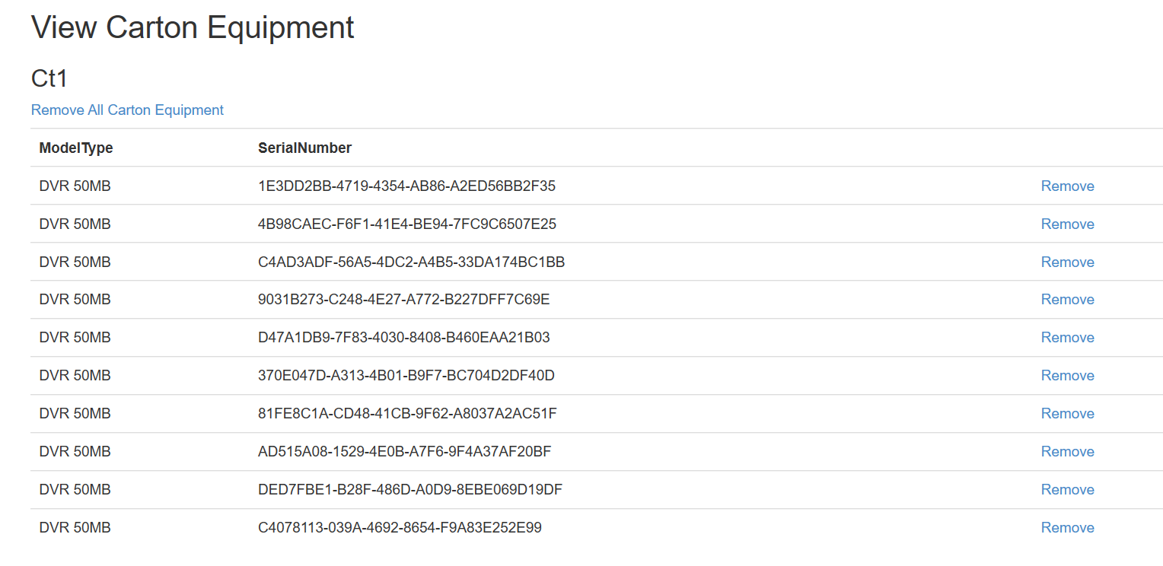

**DB Table state before removal**

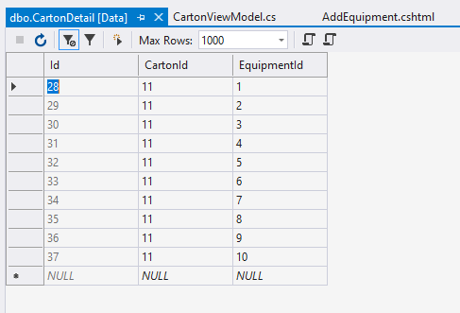

**Carton post - Remove action**

Removed the first equipment

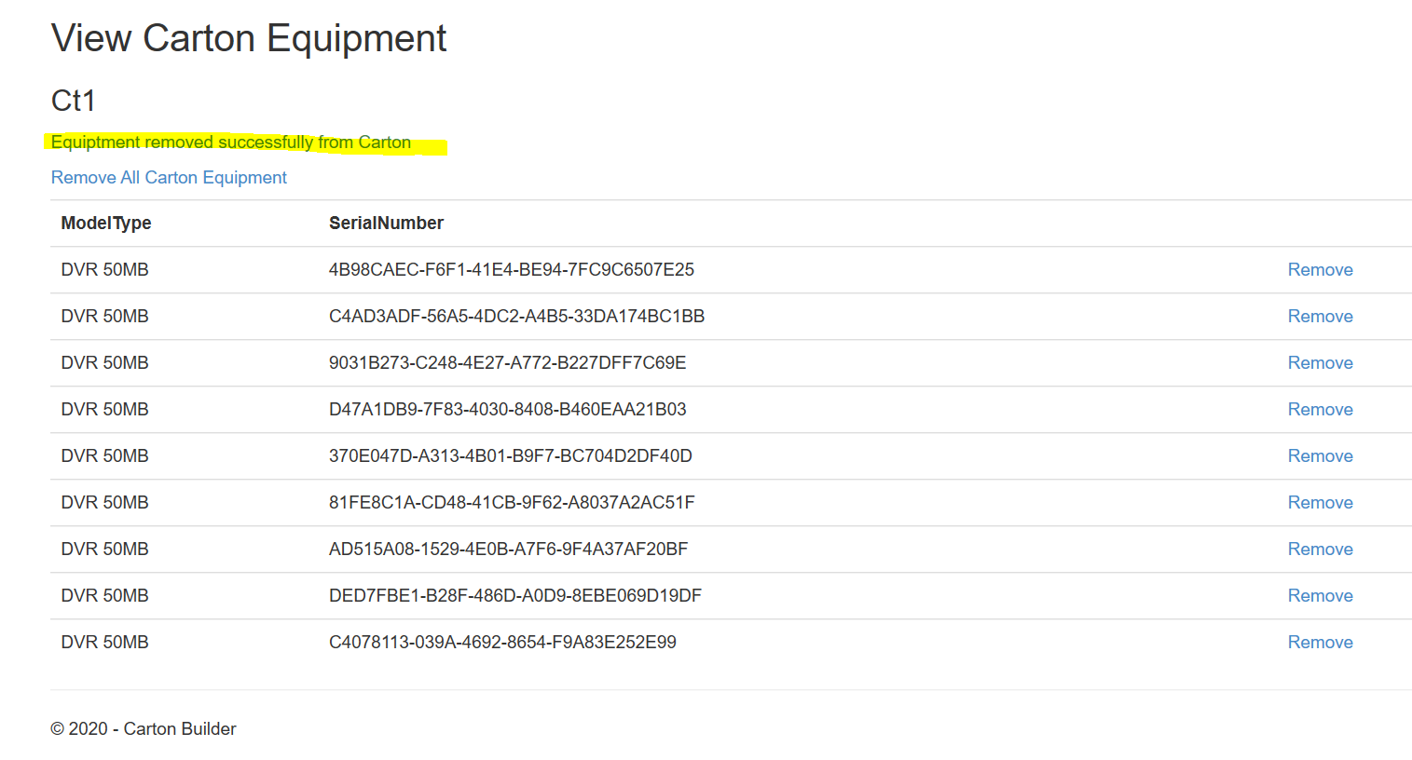

**DB Table state after removal of Equipment**

Row with ID 28 is removed

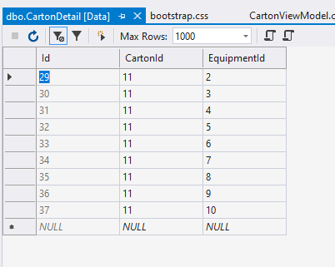

1. **Enhancements:**
2. **The carton index screen should show the # of pieces of equipment on the carton**

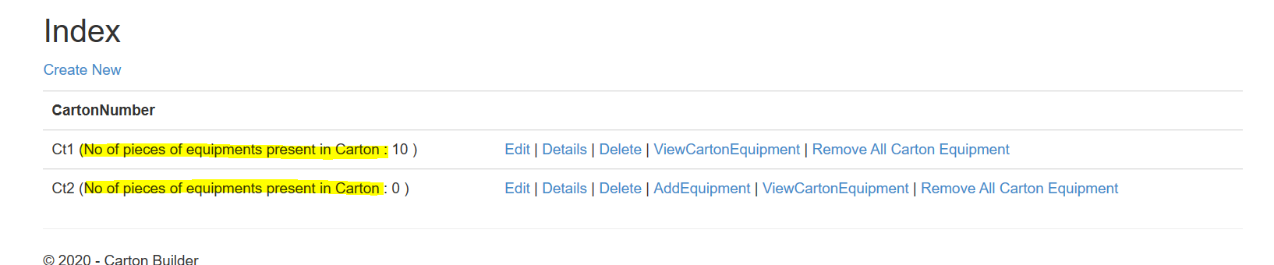

1. **We need a quick way to remove all the items from the carton with 1 click.**

Index Page

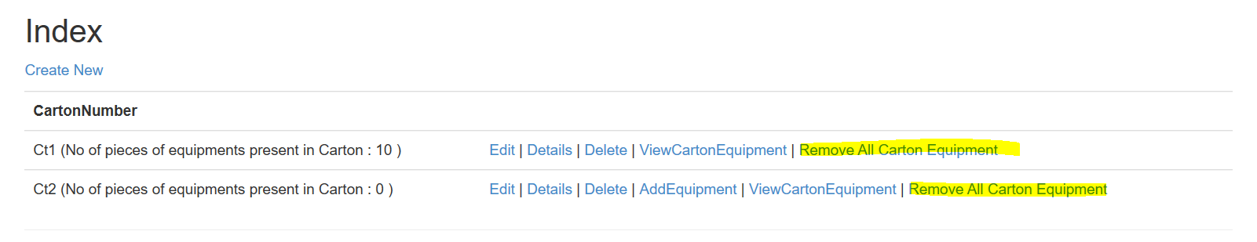

View Carton details

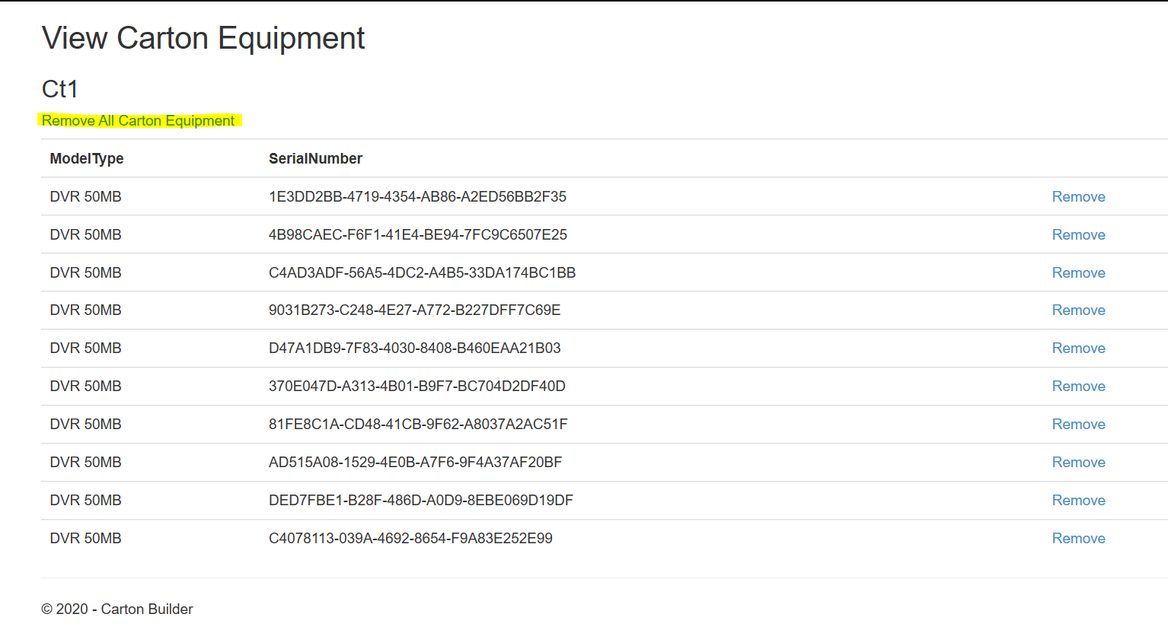

After clicking Remove All in Index Page

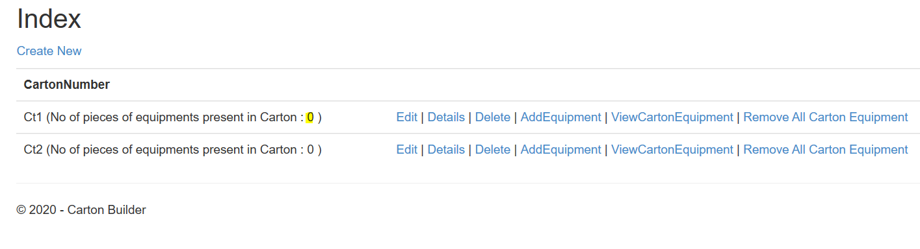

1. **BUGS**
2. **We can delete empty cartons from the system, but cannot delete cartons that have items. We**

**should be able to delete a carton at any time.**

Before -Carton 2 – Ct2 has 2 equipment

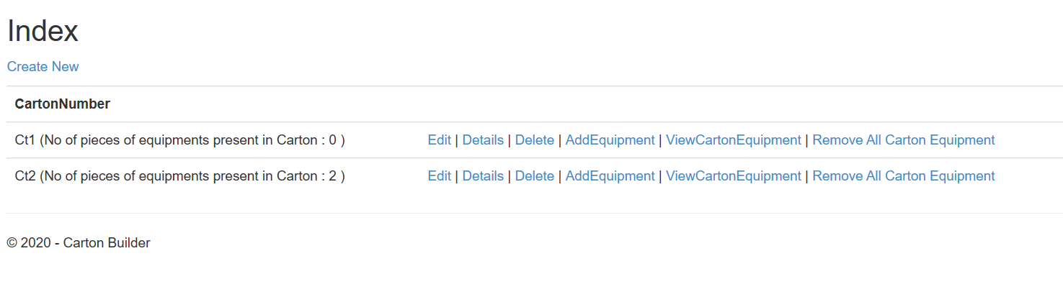

After Delete (system now checks and removes and equipment from carton details and then deletes the empty carton)

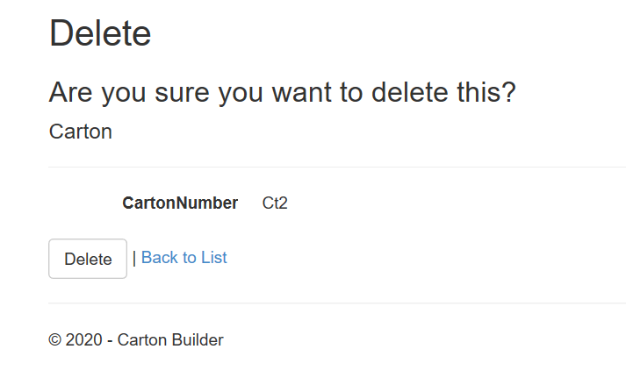

Post Delete – Ct2 no longer exists

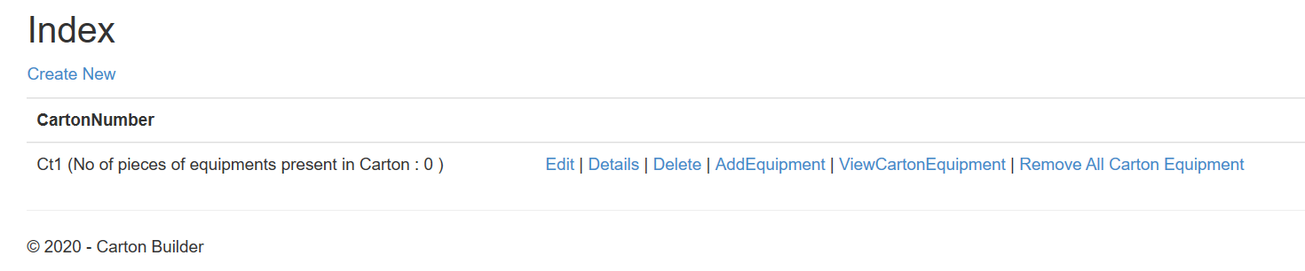

1. **We can add the same piece of equipment to 2 different cartons, this doesn’t make sense. We**

**should only be able to add a piece of equipment to 1 carton, once a piece of equipment is on a**

**carton it should be unavailable to place on another carton.**

Have setup 2 cartons – one of them (Ct1) already has an Equipment with Serial no - 1E3DD2BB-4719-4354-AB86-A2ED56BB2F35

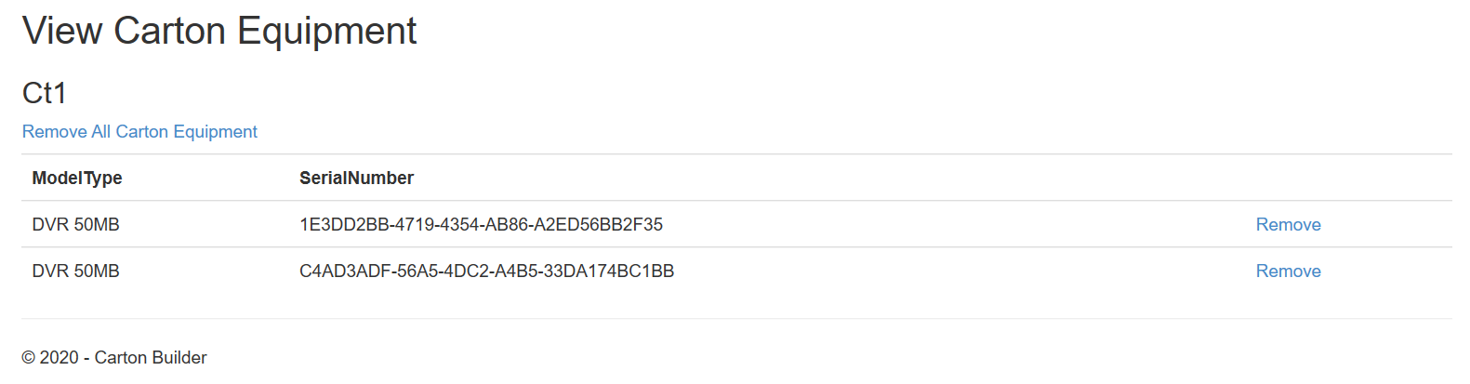

Now User tries to add Equipment with Serial no - 1E3DD2BB-4719-4354-AB86-A2ED56BB2F35 to another cart – Ct2

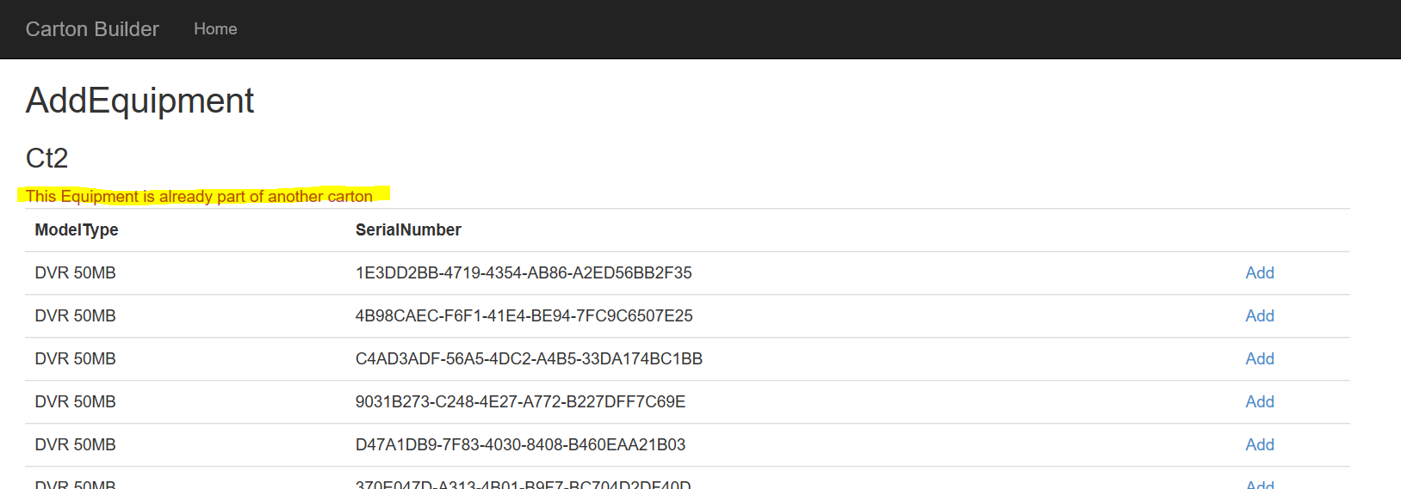

1. **Our cartons can physically hold up to 10 pieces of equipment, but the application allows us to**

**put an unlimited number of equipment on the carton, please only allow up to 10 pieces of**

**equipment on the carton.**

10 items were added before this attempt to add 11th item to Ct2

-The “AddEquipment” option no longer displays for Ct2 as it has 10

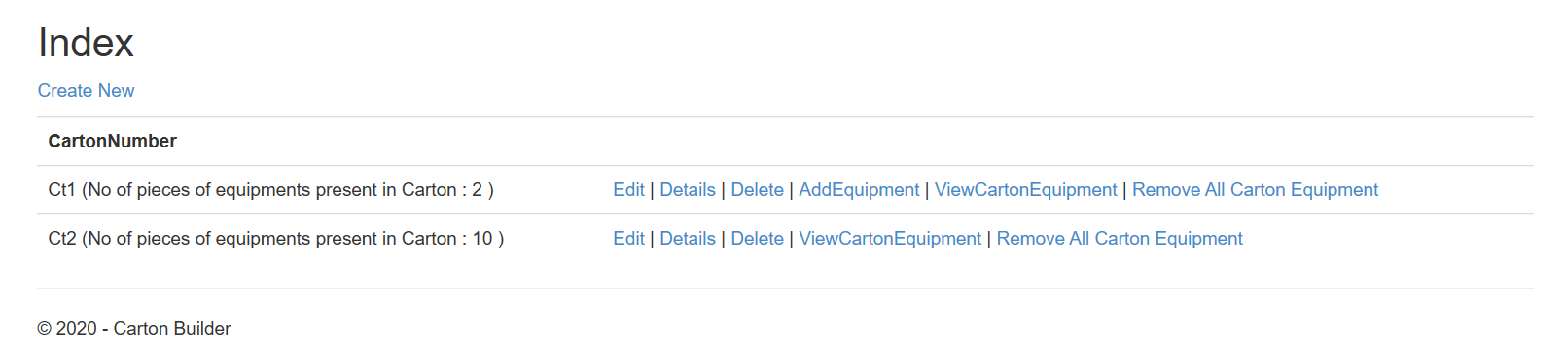

**Even if current no of items was 9 and user adds from the AddEquipment page – more than 10 -system will prevent and provide message**

